Objectives:

In this lab we started the usage of hardware in our lab we also learn how to practically develop simple circuits and then how to function them using raspberry pie.

TASK 1: Write and configure a code in python that measures the distance of SONAR sensor with an obstacle and if the distance is less than 30 cm, the green LED will get ON, else the red LED will stay ON.

CODE:
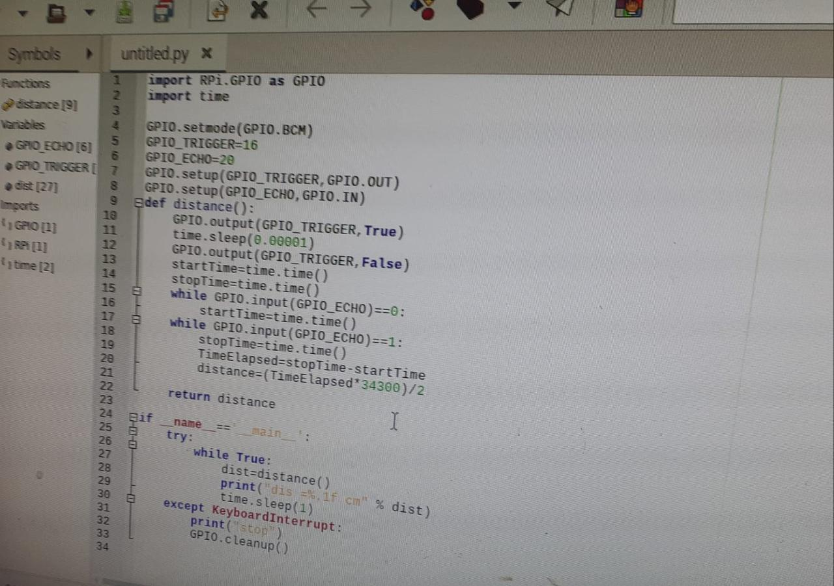OUTPUT: when the distance is less than 30 cm green light will ON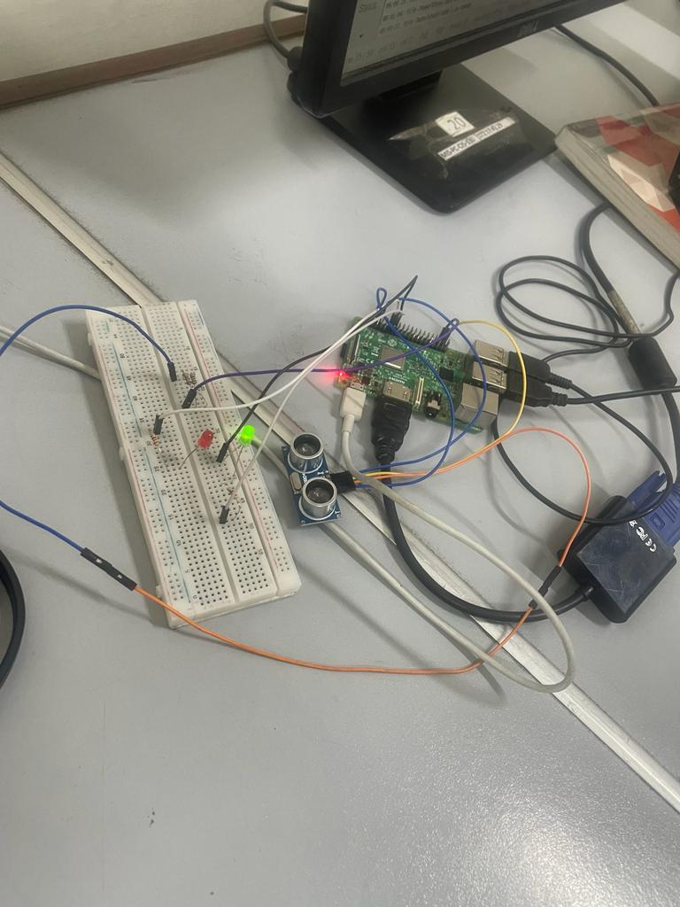
otherwise if distance is greater than 30cm then the red light will ON: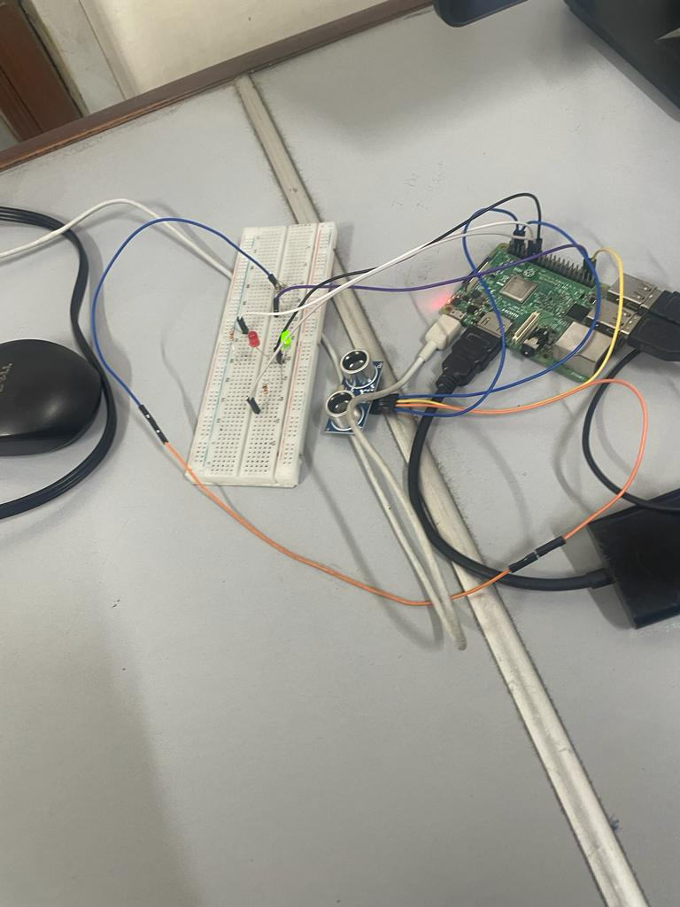

TASK 2 :
Write and configure a code in python that checks the value on the output pin of IR sensor, if the output is high it displays “ 1” on 7 segment display else display “0”.

CODE:
import RPi.GPIO as GPIO
import time

# Define the GPIO pin numbers for the IR sensor and the 7-segment display
ir_sensor_pin = 17
a_pin = 18
b_pin = 23
c_pin = 24
d_pin = 25
e_pin = 8
f_pin = 8
g_pin = 12

# Setup the GPIO pins
GPIO.setmode(GPIO.BCM)
GPIO.setup(ir_sensor_pin, GPIO.IN)
GPIO.setup(a_pin, GPIO.OUT)
GPIO.setup(b_pin, GPIO.OUT)
GPIO.setup(c_pin, GPIO.OUT)
GPIO.setup(d_pin, GPIO.OUT)
GPIO.setup(e_pin, GPIO.OUT)
GPIO.setup(f_pin, GPIO.OUT)
GPIO.setup(g_pin, GPIO.OUT)

# Function to display a digit on the 7-segment display
def display_digit(digit):
if digit == "1":
GPIO.output(a_pin, GPIO.LOW)
GPIO.output(b_pin, GPIO.HIGH)
GPIO.output(c_pin, GPIO.HIGH)
GPIO.output(d_pin, GPIO.LOW)
GPIO.output(e_pin, GPIO.LOW)
GPIO.output(f_pin, GPIO.LOW)
GPIO.output(g_pin, GPIO.LOW)
else:
GPIO.output(a_pin, GPIO.HIGH)
GPIO.output(b_pin, GPIO.HIGH)
GPIO.output(c_pin, GPIO.HIGH)
GPIO.output(d_pin, GPIO.HIGH)
GPIO.output(e_pin, GPIO.HIGH)
GPIO.output(f_pin, GPIO.HIGH)
GPIO.output(g_pin, GPIO.LOW)

try:
while True:
# Read the value from the IR sensor
ir_sensor_value = GPIO.input(ir_sensor_pin)

# Display the value on the 7-segment display
if ir_sensor_value == GPIO.HIGH:
display_digit("1")
else:
display_digit("0")

# Wait for a short time before reading the sensor value again
time.sleep(0.1)
except KeyboardInterrupt:
pass
finally:
# Cleanup the GPIO pins
GPIO.cleanup()
OUTPUT:
IF OUTPUT IS HIGH :
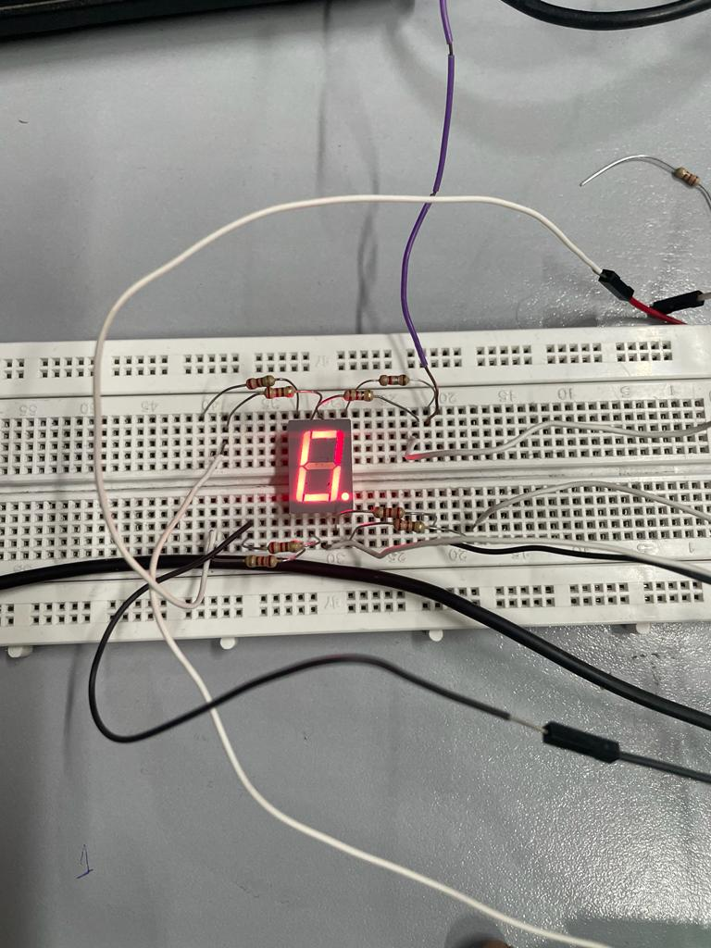
IF OUTPUT IS LOW:
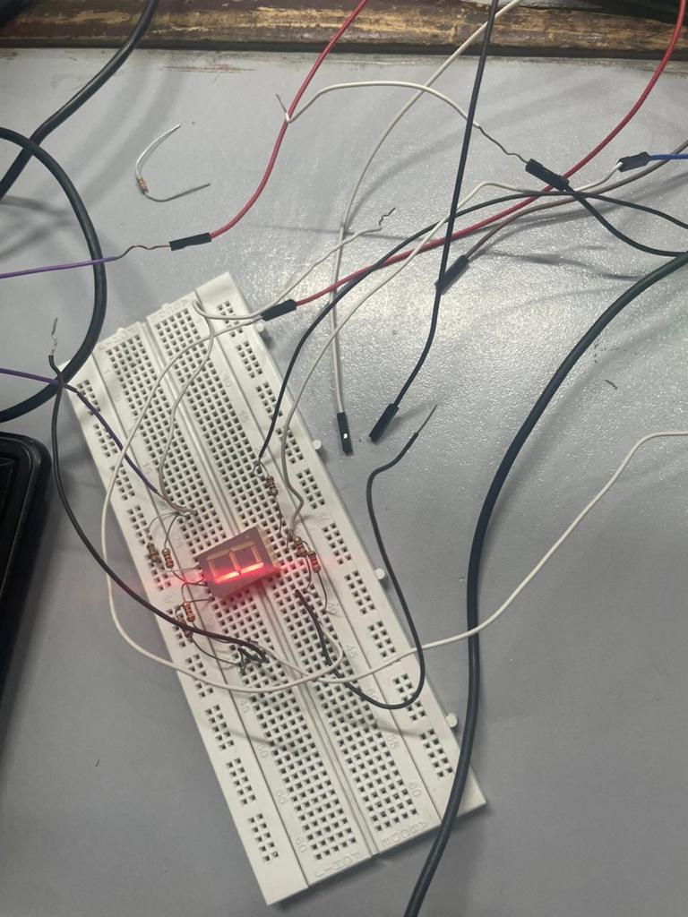

CONCLUSION:

The IoT lab experiment involved interfacing different sensors with a Raspberry Pi using Python programming to perform specific tasks based on sensor readings.

